Assignment 3 Proposal & Process Cole Dorman
System Proposal:
The purpose of this task of implementing the room logging system is to arm our level designers with much more valuable and accurate metrics about player performance in different rooms. This would allow us to test certain sections or rooms of the level in isolation, and determine distinct challenges that certain areas provide, while being able to rule out overarching challenges. This can fast track our level refinement, and it will enable us to better focus on player experience.
Process:
One of the largest issues I ran into during the component refactor was very odd misfiring of events. For starters, I was smart enough to keep the old system when migrating to the new system, so I had a working version to compare to. This meant that if everything was working correctly, I would have duplicated events for all position logs. But this was not the case. As somehow only 7 had been missing their duplicate, and it was not apparent why, as the spacing was not immediately a pattern.

My process to tackle this was firstly to ensure it was reproducible and not a fluke, which then I confirmed that I took a larger data sample by running the sim longer, and then proceeded to try and find further information. Eventually I had noticed that despite both timers being set for the same time, they grew more out of sync over time, which finally led me to find the issue.
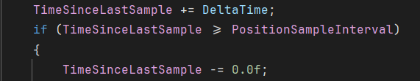
This was the issue, I had been resetting the timer each time it fired, instead of accounting for the fractional time that could have passed within code execution.
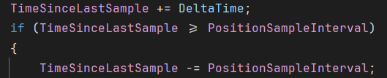
The solution is to subtract the time since we last sampled from the interval, which allows us to keep the remainder left over preventing a slow desync of a few milliseconds over time.
Proof of functionality:
I have gotten proof of concept that the logging, working successfully. As shown below the packed level actors that are in the game currently are all provided in complete verbose, due to this being a proof of concept it’s fairly hard to read, but the key details to takeaway are the cache count, which is the number of PLAs in the level. As well as that as you skim through the data you can see what each one is. E.g. [5] is BPP_WallRoofFormationA_4x2half.
